# **Sprint 4 Plan**

Risposta

Lino Le Van, Yiming Zeng, Matthew Macarewich, Nathan Lin, Trevor Gardner, Harrison Zhou

Revision #1, 3/1/2024

**Sprint 4 Completion Date: 3/12/2024**

## Goal

Our goals for Sprint 4 are refining the existing functionalities (UI/UX), implementing additional features, unit testing, code refactoring.

## Task List

* As a user, I want to work with a smooth and seamless UI so that my questions appear neatly organized and the site looks easy on the eyes.
* As a TA, I want to be able to have different access and comment abilities [to give access and distinguish from student or teacher response]
* As a student, I may want to ask questions privately to teachers or TAs [to allow me to ask personal questions which may involve code]
* As a teacher, I want to have a student name sheet, so that I can manage students (assigning them as TA & remove students).

## Team Roles

Lino Le Van - Product Owner

Yiming Zeng - Scrum Master

Matthew Macarewich - Product Developer

Trevor Gardner - Product Developer

Harrison Zhou - Product Developer

Nathan Lin - Product Developer

## Initial Task Assignments

* Yiming: As a teacher, I want to have a student name sheet, so that I can manage students (assigning them as TA & remove students).
* Nathan: As a user, I want to work with a smooth and seamless UI so that my questions appear neatly organized and the site looks easy on the eyes.
* Trevor: As a TA, I want to be able to have different access and comment abilities [to give access and distinguish from student or teacher response]
* Matthew: As a TA, I want to be able to have different access and comment abilities [to give access and distinguish from student or teacher response]
* Lino: As a student, I may want to ask questions privately to teachers or TAs [to allow me to ask personal questions which may involve code]
* Harrison: As a user, I want to work with a smooth and seamless UI so that my questions appear neatly organized and the site looks easy on the eyes.

## Initial Burnup Chart

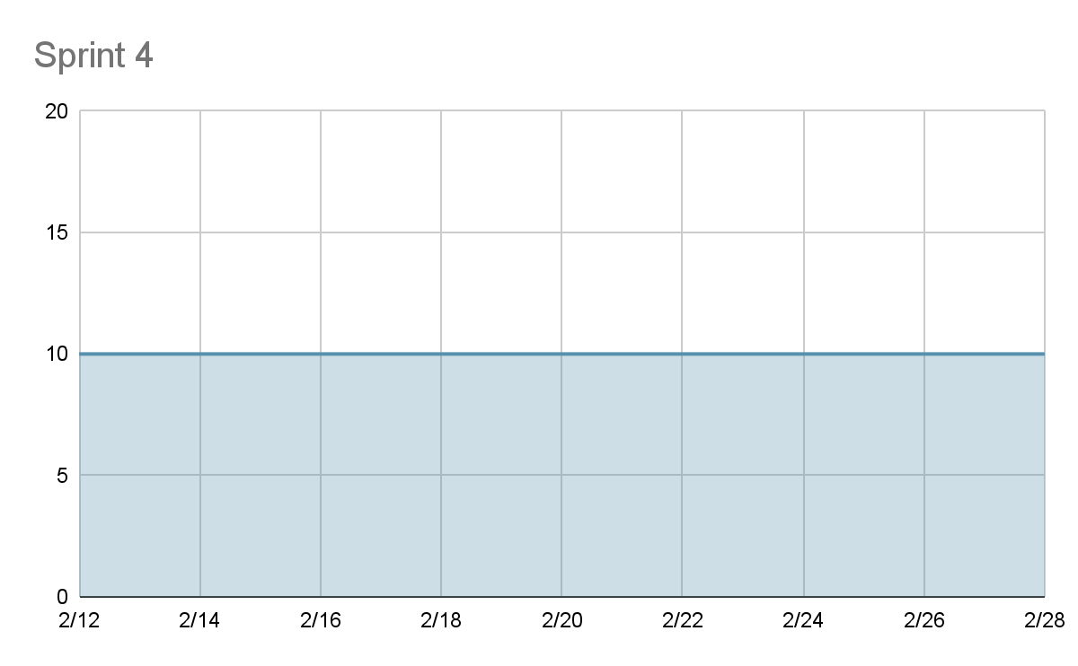

## Initial Scrum Board

<https://trello.com/b/jMbIVKPE/risposta>

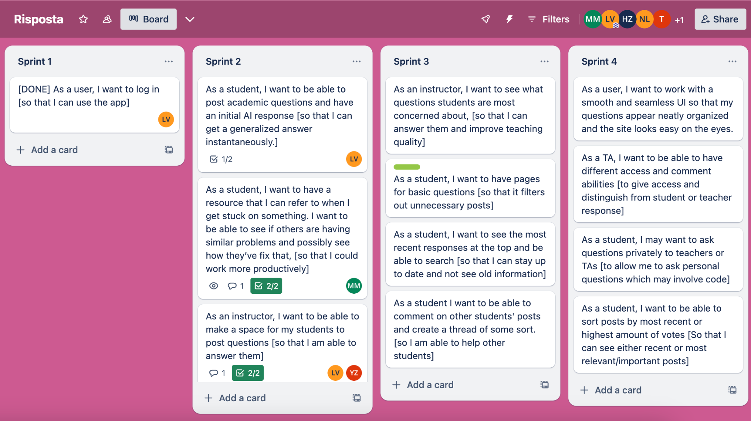

## Scrum Times

We plan to have our scrum meetings M/W/F at 9pm. Our TA meetings will be held on Thursday from 9:30-10:15.